Document control
Audience | NHS 111 DoS Leads  NHS 111 Technical Leads
Document Title | NHS 111 – Directory of Services Endpoint Template Guidance
Document Status | Final
Document Version | 1.1
Issue Date | 8th January 2013
Prepared By | Jonathan Jackson, NHS 111 DoS Readiness Manager

Version | Date | Name | Comment
0.1 | 29.05.12 | Jonathan Jackson | Initial Draft for comment
0.2 | 30.05.12 | Jonathan Jackson | Updated following feedback from Tony Yates.
0.3 | 01.07.12 | Jonathan Jackson | Updated following further feedback plus addition of “comments” field. Endpoint Template added as Appendix 1
0.4 | 04.07.12 | Jonathan Jackson | Further clarifications following NHS 111 Technical Leads meeting
0.5 | 13.07.12 | Jonathan Jackson | Clarification of Telephone types in 2.3.7 and 2.3.10. Appendix A updated with template saved in earlier version of Excel to remove compatibility issues.
0.6 | 14.09.12 | Jonathan Jackson | Updated to reflect new endpoint template and process for updating DoS.
0.7 | 24.09.12 | Jonathan Jackson | Addition of Appendix B to give further guidance on populating interim solution for Endpoint details on DoS.
1.0 | 20.12.12 | Jonathan Jackson | Final Version for release. Clarification of governance to support interim (and future) functionality to allow DoS Leads to enter endpoint details direct to DoS (Sections 3 and 4). Clarification that entry of NACS/ODS code (Section 2.3.5) is mandatory.  Clarification on use of template to record Post Event Messaging endpoint information (Section 2.3.10)  Template (embedded at Appendix A) updated to version 1.42 to reflect authorisation structure outlined in Section 3.2.
1.1 | 08.01.13 | Jonathan Jackson | Remove references to DTS as a valid transport.

Contact details | jonathan.jackson@dh.gsi.gov.uk

Document control 1

Contents
Contents 2
1 Introduction 3
1.1 Purpose 3
1.2 Summary 3
1.3 Scope 3
1.4 Audience 3
1.5 Status 3
1.6 Related documents 3
1.7 Structure 4
2 Populating the Template 5
2.1 Overview 5
2.2 Assumptions 5
2.3 Populating the DoS Endpoint template 5
2.3.1 Order 5
2.3.2 Service Name 5
2.3.3 Service Type 6
2.3.4 DoS Service ID 6
2.3.5 NACS/ODS Code 6
2.3.6 Comments 6
2.3.7 Transport 6
2.3.8 Format 6
2.3.9 Interaction 7
2.3.10 Business Scenario 7
2.3.11 Endpoint Address 7
3 Using the template 9
3.1 Completing the template 9
3.2 Governance 9
4 Maintenance 10
4.1 Updating/Adding Entries 10
Appendix A 11
Endpoint Checklist Template 11
Appendix B 12

Purpose

Introduction
This document has been prepared to give guidance on completion of the DoS Endpoint template, and the processes to be followed to load the endpoints to DoS, and make changes to entries following the initial upload.

Summary
Message flows from NHS 111 provider to downstream services is reliant on the DoS holding endpoint details for all the relevant services. The endpoint details will not only include an address based on Service ID and NACS code, but also information about the transport mechanism that can be used to transmit the NHS 111 call information to the endpoint service in a format that can be interpreted and displayed at the receiving service.
To aid in the collection of the relevant information – a template has been created to allow DoS leads from each area to launch NHS 111 to record information for each service populated on the DoS. The areas Technical Lead can then record the relevant endpoint information for each service. This document provides guidance on the completion of that Template.

Scope
This document covers initial completion of the DoS endpoint template, and the processes for updating any changes to endpoint details following initial population..

Audience
The primary audience for this document are DOS leads and Technical Leads in each area launching the NHS 111 service.

Status
Final version for distribution

Related documents
This document should be read in conjunction with the following documents:
- NHS 111 DoS Endpoint Checklist: An Excel Workbook recording DoS Service details and endpoint information.
- NHS 111 Interoperability Specification: Sets out the interoperability requirements for sharing 111 information

Structure
Overview of the document, summarising each section:
- Section 2 – Populating the template: provides information on what data is required to be recorded in the spreadsheet, the sources of the data, and who should be completing the template.
- Section 3 – Using the template: describes the process once the template has been completed.
- Section 4 – Maintenance – outlines the process for changing endpoint details and adding details for new services.

Overview

Populating the Template
The Directory of Service underpins NHS 111 in ensuring that a patient is directed to the most appropriate “local” service for their needs, having the relevant clinical skills to diagnose and treat the patient.
It is also important that information relating to that patient and the assessment of the patients symptoms which resulted in them being directed to the service is passed to that service in a timely manner to ensure that clinicians have a full understanding of the patients needs in order to provide the most appropriate treatment.
National Quality Standards also require the patients own GP to have sight of each contact made with the NHS 111 Service, and the outcome of that contact. The NHS 111 service must therefore ensure that copies of call information are transmitted to the patients GP.
The Directory of Services will hold the endpoint information for each service subscribing to receive data, to ensure that the information required is transmitted to that service in the most appropriate way so that systems used can present the information to the end user in a uniform, understandable format. A standard, simple template has been created to assist with the collection of the endpoint data. Where the items required for transmission to local services such as GP’s are not ITK compliant or using NHSmail, local areas should use whatever technological means they can to achieve the specification and maintain local endpoint rules based on recipient preference.

Assumptions
Data to be collected on the template is based on data items held in the NHS Pathways/CMS DoS. However, it can be assumed that similar data items will exist if a different Directory of Services is in use by the NHS 111 provider.
Note: All data items must be populated with the exception of the “Comments” field which can be left blank if not required.

Populating the DoS Endpoint template

Order
Gives a priority for the current service/endpoint combination where more than one endpoint is available for that service.
This will need to be set by the NHS 111 Technical lead once the number of different endpoints for each service is understood and recorded.

Service Name
The name of the Service as recorded on DoS – to be completed by the DoS Lead

Service Type
Value from a drop down list as a sense check for the high level service type. Note – this is not a direct match to the team types used when profiling services on DoS – to be completed by the DoS Lead.

DoS Service ID
Service ID as recorded on the DoS (available from Service Status Report) – to be completed by the DoS Lead.

NACS/ODS Code
NACS code for the current service – to be completed by the DoS Lead.
Please Note: This data item is mandatory and must reflect the value already entered against the Service on DoS. Null entries will result in the template being returned to the originator.

Comments
Freetext field recording information which may need to be passed to the caller via the call advisor. The host system of the NHS 111 service handling the call will be required to display these comments should the service be selected to allow the call handler to pass on the information while on the call, or make changes to usual working practice – To be completed by the DoS Lead

Transport
Method by which the message will be transmitted to the endpoint – values will include “itk” (NHS 111 Interoperability Specification v2.1 or greater), “email” or “telno”. Selectable from a drop down list.
To be completed by the Technical lead.

Format
The “payload” to be delivered to the endpoint – values include Clinical Document Architecture (CDA), HTML and PDF (rendered CDA) – to be completed by the Technical Lead. Selectable from a drop down list.
Where transporting data as HTML or PDF by e-mail, the rendered HTML or PDF should be sent as an attachment to the e-mail message as some downstream services/systems will use the attachments as part of existing workflows. Providers can also opt additionally to embed the rendered HTML or PDF document as the body of the e-mail so that it can be easily read by the recipient when the e-mail is opened.
Note: For Transport value of “telno” the Format field should be left blank

Interaction
Selectable from a drop down list. Table 1 below shows the relationship between Service type (2.3.3 above) and interaction.
NOTE: The interaction field can (and should) be left blank if the transport type is “telno”

Service Type | Interaction
ED | urn:nhs-itk:interaction:primaryEmergencyDepartmentRecipientNHS111CDADocument-v2-0
GP (Business Scenario = “Primary”) | urn:nhs-itk:interaction:primaryGeneralPractitionerRecipientNHS111CDADocument-v2-0
GP (Business Scenario = “Copy”) | urn:nhs-itk:interaction:copyRecipientNHS111CDADocument-v2-0
All others | urn:nhs-itk:interaction:primaryOutofHourRecipientNHS111CDADocument-v2-0
Table 1

Business Scenario
Selectable from a drop down list: Indicates if the endpoint is the main recipient for the message. In most cases, except for Service type “GP”, the entry will only be “Primary”. For Service Type of “GP” the Primary endpoint will be used to receive messages from dispositions where the patient is being directed to their own GP and the GP needs to have direct access to the call information.
The “Copy” endpoint will be used for Post Event Messaging (PEM) where a GP needs to only receive a copy of a call report where a patient has been treated by another service as a result of a call to 111. Note: To enable PEM for to be sent to a GP, a separate entry will need to be created as described; creating a single “Primary” entry will not automatically create the necessary detail to send PEM to the GP.
To be completed by the Technical Lead

Endpoint Address
Contains the endpoint address for the service.
For e-mail, this can only be a valid nhs.net address
For “telno”, this will be a valid phone number (DDI) on which a patient can be warm transferred to the service. It is not to record any phone number on which a member of the public can directly dial that service and the call handler must not share this phone number with the caller.
NOTE: Only fully tested endpoints will be accepted – all connectivity/message flows must be fully tested outside DoS, and only following successful end to end testing should the endpoint be submitted.
To be completed by the Technical Lead.

Completing the template

Using the template
Completion of the template will be in 2 stages.
Columns D to H (2.3.2 to 2.3.6 above) will need to be populated first by the DoS Lead. Prior to go live, the only services mandated to transfer data will be Out of Hours services, so these must be included as a minimum.
Once the DoS Lead has completed the necessary service details, they will pass the spreadsheet on to the Technical Lead for completion of column C and I to M (Section 2.3.1, 2.3.7 – 2.3.11 above).
The template can only be completed once the relevant services are populated on DoS, and end to end testing with the relevant endpoints has been completed. This means that the DoS must not be used to test messaging flows between the NHS 111 provider system and the receiving system. These messaging flows must be tested separately, and the endpoint details submitted/entered to DoS only when successfully tested. For fully compliant ITK systems, this means that Live endpoint details must only be submitted/entered on DoS when the relevant endpoint certificate have been awarded.

Governance
It is essential that the data recorded on the endpoint template has been validated by all parties by whom it will be used. Therefore, all entries must be approved/authorised by the submitting DoS Lead, the NHS 111 Technical Lead for the area, and a representative of the NHS 111 provider system supplier. The authorisation should be captured using the box at the top of the “Endpoints” tab in the template Excel Workbook. Once all parties have recorded their authorisation, the completed template can then be submitted for final validation to the NHS 111 Readiness manager. No further processing of the data on the template will be done if any of the above levels of authorisation is incomplete.
Please ensure you allow sufficient turn around times in to your plans to allow for all parties to review and authorise the endpoint data.

Updating/Adding Entries

Maintenance
Changes to the DoS administration screens have be made to allow the endpoint details to be recorded against each DoS service. The batch uploading of endpoints will no longer be completed by the CMS Pathways DoS team when DoS leads have access to these screens.
An initial interim solution has been developed which allows DoS leads with the appropriate role (editEndpoint) to copy and paste the data in the “value” field on the “KeyValues” tab of the Dos Endpoint template into a new field on an “Endpoint Details” section on the DoS admin screen for the relevant service. Up to 4 different endpoint entries can be recorded for each service. See Appendix B for screen shots.
This solution allows DoS users to work with Technical leads and update any endpoint information as necessary. Corrections/amendments to any technical detail can be made on the DoS Endpoint template, and the resulting new “value” entry can replace the existing entry on the DoS.
A longer term solution will be delivered which will replicate data entry as per 2.3.1, 2.3.7 – 2.3.11 above and will therefore calculate the “value” field based on the entries made into the relevant fields on the new “Endpoint Details” section of the DoS Admin screens. Once this full solution has been delivered, there will be no requirement to complete the DoS Endpoint Template.

Endpoint Checklist Template

Appendix A

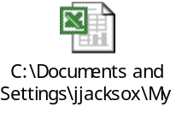

Appendix B

A new section “Endpoint Details” is available for each service. Users with the role of “editEndpoint” will be able to enter or amend endpoint details by clicking on the pencil icon displayed in the section.
In Edit mode, 4 boxes will be displayed:
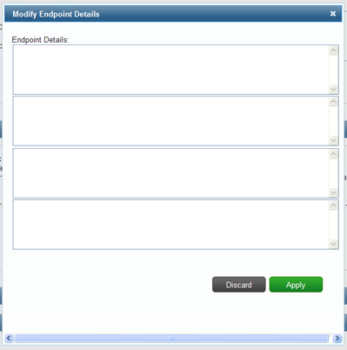

The information to paste into the endpoint details field can be located on the “KeyValues” Tab of the populated Endpoint Template Excel Workbook.
Simply copy the “Value” field for the appropriate service.

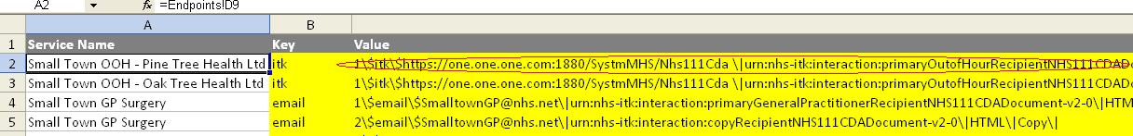
This value can then be pasted into the relevant “Endpoint details” field for that service. Up to 4 separate entries can be made for each service. Once data entry is complete, the changes can be saved by clicking on the “Apply” button as usual.

For services with existing endpoint details – these will be displayed as below:
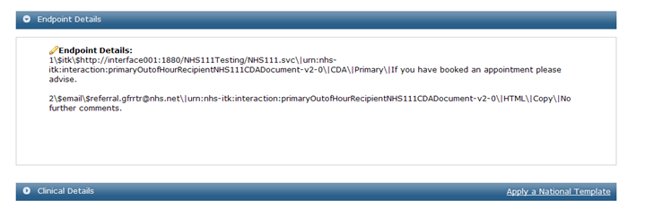

The user can amend or delete the details by clicking on the pencil icon. The existing details will be populated into the input screen and can be deleted or overwritten with new data as required:
